**NGO**

**PROJECT PROPOSAL**

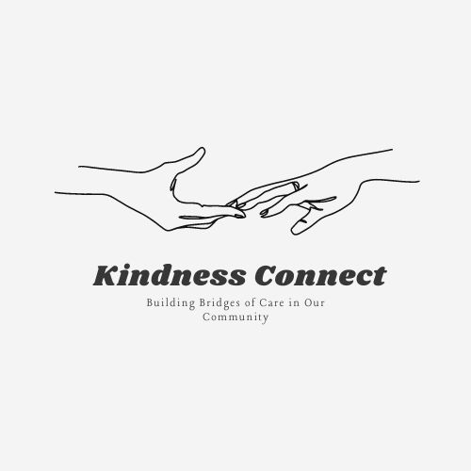

**Landline: 011-566-4793**

**Contact number: 083-595-5918**

**Email: kindness_connect@gmail.com**

Table of content

* ***Cover page....................................................p1***
* ***Table of contents..........................................p2***
* ***Problem statement.......................................p3***
* ***The Rationale for the Project.........................p4***
* ***Goal and Objectives of the Project................p4***
* ***Approaches and Methods............................p4***
* ***Expected Impact and Outcomes..................p5***

**Problem Statement**

The economy of today has resulted in many people in communities facing poverty. There is an enormous difference between a high standard of living and a low standard of living in this country and it is noticeably clear. The people in our communities are not working because they do not want to but there are just no job opportunities available for them. Some do not have the finances to further their studies whereas some have graduated but cannot get jobs. This is resulting in the crime rates in communities increasing because that's how people make means to survive and feed their families. People are being robbed and their money and cellphone are always taken, and their cellphones are being sold to receive cash. “An estimated 1.5 million incidences of theft of personal property occurred in 2022/23, affecting 1.2 million individuals”, and still increasing. Due to hunger these are one of the things that take place in communities.

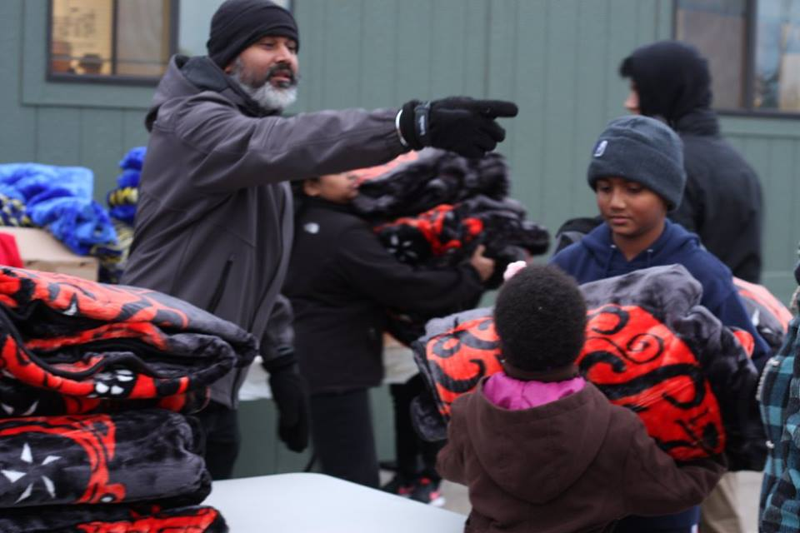

**The Rationale for the Project**

The project is extremely necessary in communities as it will help families in need. This project will help in reducing the chances of teenagers indulging in criminal activities as they grow up. This project will be providing families with all the things they need to survive. Job opportunities will be created as volunteers will be needed.

**Goal and Objectives of the Project**

By the end of this project there will be an improvement in these communities. Yes, change will not happen in a short space of time but in 3 months change will be visible. By the end of this project our plan is that we should have built a bridge between the poor and the rich. We will have reduced the chance of people being robbed as not so many people will be suffering. We would have created employment for people that are staying at home as we would need more people to make the project a success.

**Approaches and Methods**

This project will be achievable by receiving more than enough donations. And people should be scared to donate the little amount that they have because it means a lot. We plan to look at what is lacking in communities and tackle one problem at a time. Programs will be created for teenagers that lack information about puberty and adolescence. Programs will be a success as we will receive help from the department of education to assist us in informing teenagers and children about information they do not know about. We will be working together as a group to ensure we cover most parts of Soweto, and that will be achievable by having many volunteers. The head office will be working with the community leaders appointed to know what is needed from us. Forms will be given out every 2 months and ratings and opinions will be given so we can see where we need to improve. Updates will be received by the head offices, indicating we are moving on the right path.

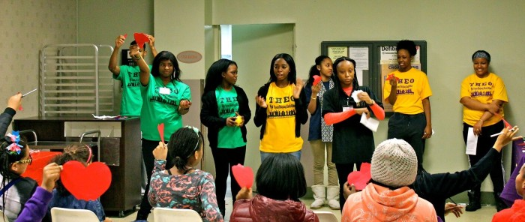

**Expected Impact and Outcomes**

In the brief time we expect to see families having all the basic things they need. We want to impact families in a positive way by changing communities all over Soweto. In the long term, you would have built a bridge between the poor and the rich. The rate of crime will decrease in communities as people will be living a better life. We are planning to clean the streets by creating employment as people will be volunteering to work for the organization.

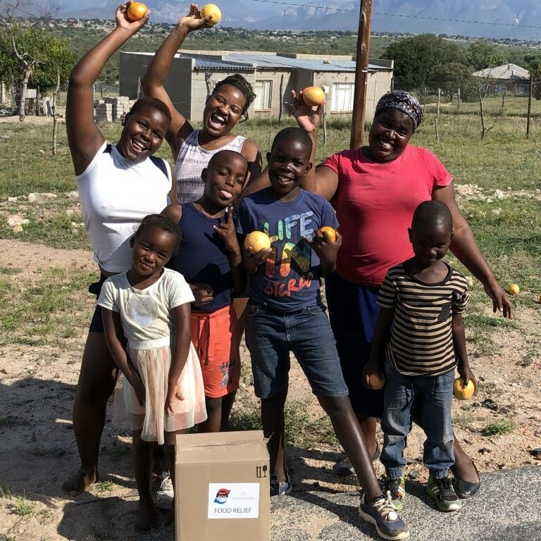

**IMPROVEMENTS TO PART 1**

The first change that I've made on the website for all webpages was that in the header tag I change the navigation bar and aligned it to the center, also changing the donate button by making the background of it orange and adding a sign-up button and making the background blue. I have reduced the size of my logo and put it inside the header making it part of the navigation bar and changing the logo from being square to a circle.

I then changed the background of the footer and made it black with the text being white and changing the structure of how my text was positioned putting it in the form of a table and aligning the information to the center. I removed the inline styling and opened a CSS file and also used internal styling.

CHANGES IN INDEX

In the home page I've aligned my content in the center and reduced the width and the height of my welcome image and also making my h tags bold and changing the color too sky-blue to attract a reader's attention.

I removed the <label class=”logo”>Home</label> that was supposed to be on line 286.

I added the <button class=”Register” onclick=””>Sign up</button> on line 295 and the

<button class=”Donate” onclick=””>Donate</button> on line 296.

Opened <div> and </div> tags on line 294 and line 297.

I opened a <div class=”hamburger” id=”hamburger”> on line 298

I used a <footer class=”footer”> on line 357

CHANGES IN ABOUT US

In the about us of page I added an image that's on the home page and I have moved my text to the side of my image using the float tag. The part that talks about the values of the organization I aligned to them center. I've also changed the format of the images in the meet the team and made it a slide show instead of pictures that are in a list.

CHANGES IN PRODUCTS AND SERVICES

I've changed my age tags to orange to also grab the attention of the readers. And reduced. The width and height of images.

CHANGES IN CONTACT US

Firstly, I removed the image then aligned my text to the center and created borders around my information.

CHANGES IN DONATE

I Removed the picture that was there when you opened the web page and added a picture in the background.

CHANGES IN SIGN UP

I’ve Changed the background color of the sign-up page to orange, also adding the float tag so that where you must enter your information can be on the left-hand side.

Line 351 to 355 i used the <rect> tags